Navigation user manual

# 1 – Global Use

In this application you will control an avatar seen at the third person view

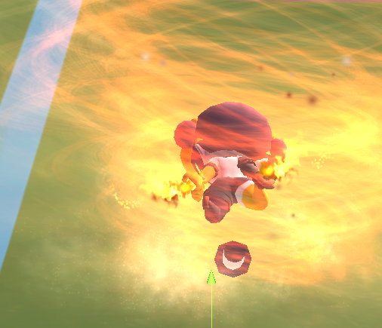

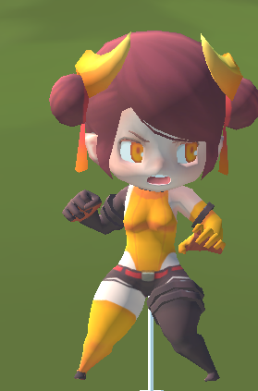

Figure 1 The avatar grounded and flying

The goal is to navigate through an Asian map to valid checkpoint or by walking and jumping or will flying. 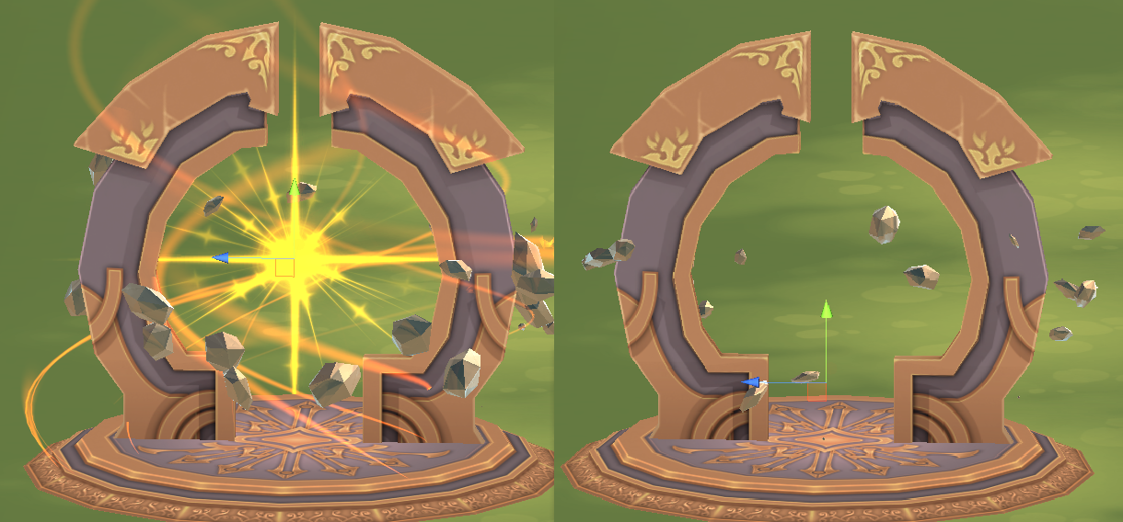

Figure 2 Left checkpoint, right validated checkpoint

A set of checkpoint has been placed on the map, a arrow on your avatar will point to the next checkpoint, but you can collect them in any order.

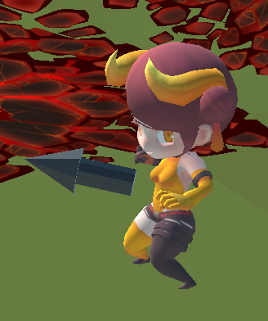

Figure 3 Follow the arrow

An area of effect has been placed close to the spawn to reset all the checkpoint, you can trigger it at any time or after collected all the checkpoint (then the arrow will point toward it).

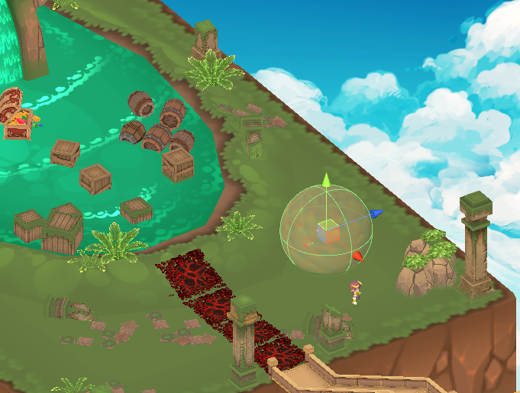

Figure 4 Area of effect to reset the checkpoint

Some trap has been set up on the way, triggering the trap cause you to respawn at the level beginning

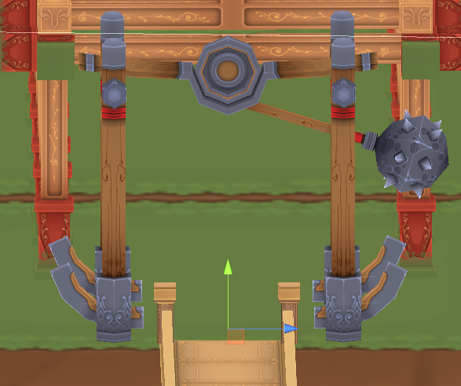

Figure One of the trap

The map has been delimited by another AOE, if you exit this AOE you will be teleported at the spawn position at the level beginning.

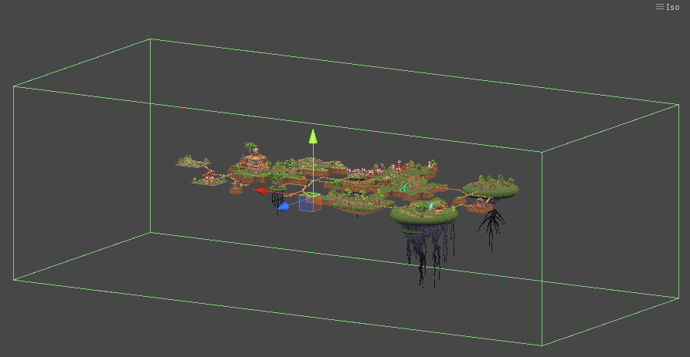

Figure Map delimitation

# 2 - Input to the avatar

At any time the robotic arm position and rotation is fixed, getting the arm away from this position will apply a force and a torque to this attached position and rotation.

You can shift the arm position and rotation by pressing the clutch handle arm button, then the attached position will be shifted.

## Custom Bubble

By default the custom bubble is disabled, you may want to activate it by pressing the “Left shit + B” keys on your keyboard.

It’s useful as you want to be in the middle of the immersia room and as far as you can be from the wall that you will face to have the better experience.

## Walking input

Here are the basics commands that the avatar can execute

* Idle
* Walking
* Running
* Jumping
* Rotating

### Idle

By putting the robotic arm on the attached position and rotation, you will disable all movement input to the avatar then it will just stay here. The force and torque help you to get to the attached position.

### Walking and Running

You can displace the robotic arm handle forward or backward to make the avatar move forward or backward. The more you displace the handle, the faster the avatar will move.

### Jumping

By raising the handle above a certain threshold you will trigger the Jump command of the avatar, then the avatar will jump.

While the avatar is jumping you can still execute all the other command as you have an air control.

### Rotating the view

You can rotate the avatar (and so the view) by rotating the handle on the vertical Axis, then the avatar will rotate on its vertical axis at its rotation speed.

## Flying input

To enter the avatar flying mode you need to press the robotic handle button. You can enter the flying mode any time by keeping pressed the button and exit the mode by releasing the button.

Basically the way to control your avatar while flying is the same than when you are waking, but you can now displace the arm on the 3 axis to displace your avatar on the 3 corresponding axis.

You can also rotate the handle on the 3 axis, then the same rotation will be applied to the avatar.

The vertical rotation (Yaw) is free, but the pitch axis and roll axis has been clamped at a certain value.

You may want to remember that the avatar will move along its coordinate system, so if your avatar has pitch, pushing the handle will make him move according the pitch direction as a real plane and not in a straight horizontal line.

The same goes for the roll that will control the direction the avatar will pulling the handle upward or downward.